INSTALLED DOCKER :

1)ENABLING DOCKER SERVICE AND USER PERMISSION:

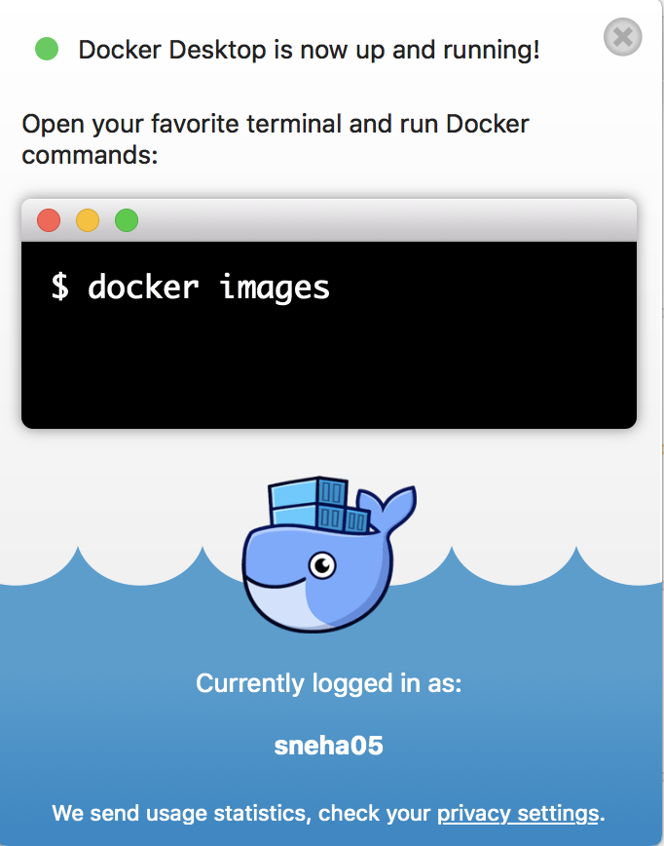

2) HELLO- WORLD:

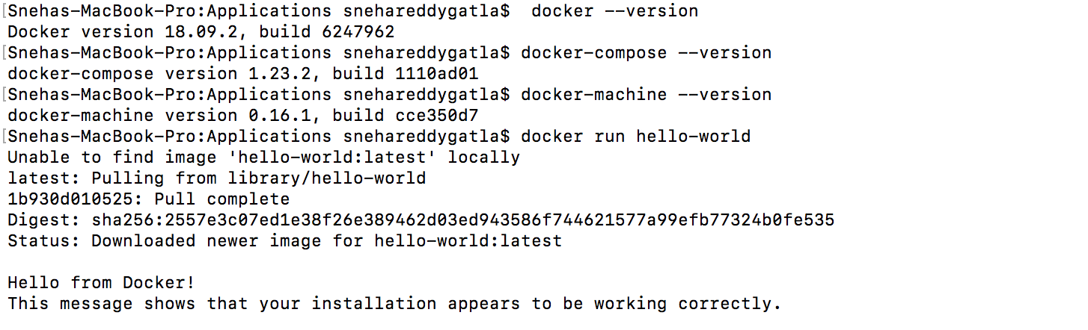

3)PULL IMAGES:

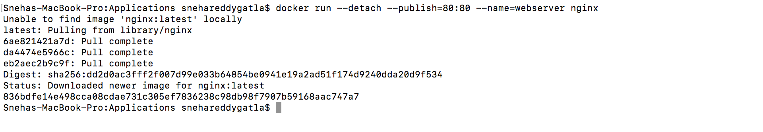

4)